CS4D2A – Information Management II Project report:

For this project, each student is required to create a database using the Oracle DBMS. The database a student implements is at the discretion of each individual. For this project, I have decided to model 5 of Gordon Ramsay’s restaurants. The reason I chose to model a restaurant is because a restaurant has a relatively high complexity. It can have staff, clients, menus, equipment, suppliers, dishes, reservations and the actual restaurant itself to name but a few possible model-able features.

For this database, I have several restaurants, and each restaurant will employ several staff, serve several menus which list several dishes. The restaurant will serve several clients, who can also make several reservations with the restaurant and order several dishes from several menus.

The six entities that I have decided to model are listed as follows:

1. **Restaurant**:
   1. Each restaurant entity will have a restaurant_id; the Primary key of the table, a phone_number, a capacity, a name, and an address which is a composite attribute, comprising of country, state, city and street_name.
   2. Each restaurant will serve many menus, employ many staff and will manage many reservations.
2. **Clients**:
   1. Each client entity will have a client_id; the Primary key of the table, a phone_number, email_address, and the client's name will be composite attribute, comprising of their first and last names.
   2. Each client can make many reservations in many restaurants and can order many dishes from many menus.
3. **Staff**:
   1. Each staff member has a staff_id; the Primary key of the table, a phone_number, a composite name, comprising of first and last name, their position in the restaurant and their home address, which is a composite attribute comprising of country, state, city and street. Each staff will also have a restaurant_id which will act as a foreign key to the table - as each staff member must work in a restaurant.
   2. Each staff member is employed by one restaurant.
4. **Menus**:
   1. Each menu will have a menu_id; the primary key of the table, an expiry_of_menu, number_of_items and type_of_menu attributes.
   2. Each menu is used by one restaurant and each menu provides many dishes.
5. **Dishes**:
   1. Each dish has a dish_id; the primary key of the table, a price, name and a description.
   2. Each dish is provided by many menus and can be ordered by many clients.
6. **Reservations**:
   1. Each reservation has a reservation_id, the primary key of the table, a restaurant_id and client_id; as foreign keys, notes, number_of_people, time and date.
   2. Each reservation is managed by a restaurant and a reservation is made by a client.

There were some security features added with the aim of restricting what members of staff can view; for example, a waitress shouldn’t be able to look into the personal, staff record of the chef, and vice versa, but the manager of the restaurant should be able to do that.

To fully and effectively model this system, three more entities were added; these are **course_for_customer**, **menu_in_restaurant** and **dish_on_menu**.

There were also some triggers implemented in order to ensure that the integrity and accuracy of the database is upheld, for example, when a restaurant is closing down, all of the tuples with that restaurant _id should also be deleted, such as in reservations etc.

The security and referential integrity modelling choices I have made will be discussed later in this report.

**Entity Relationship Diagram:**

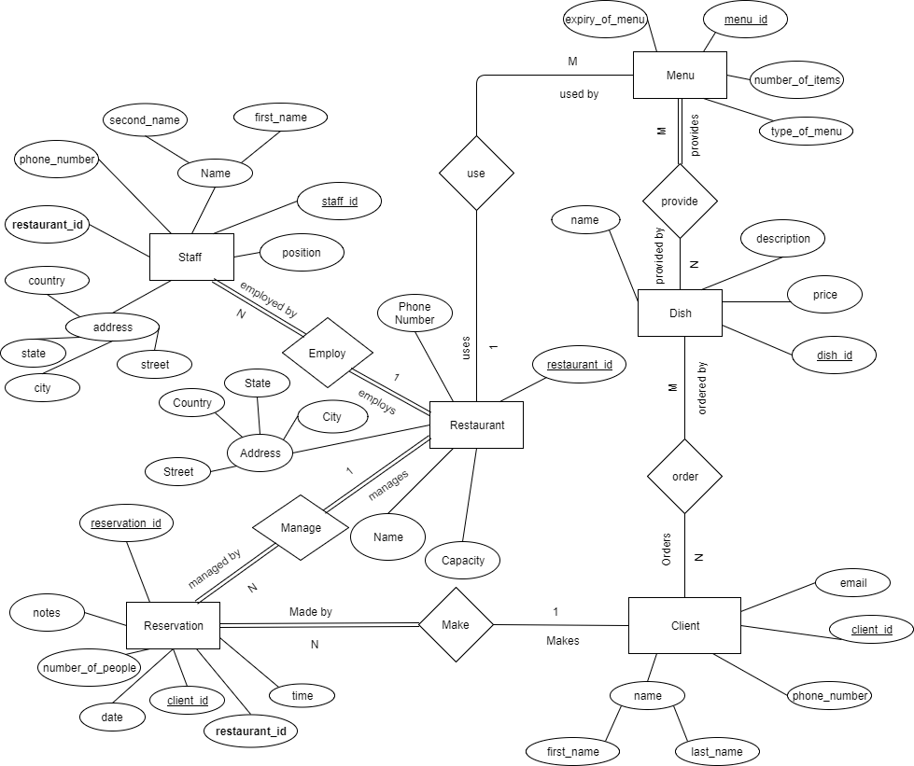

1. **Note:**
   1. In all three of my diagrams supplied, if a value is underlined it is a primary key. If the value is emboldened, it is a foreign key.
   2. With regards to Normalization, the three forms of normalization are 1s, 2nd, 3rd and Boyce-Codd (3.5) normal forms. Each of the normalization constraints were already met during the modelling stage in this project, and hence, no further decomposition was required for this database.

**Relational Schema:**

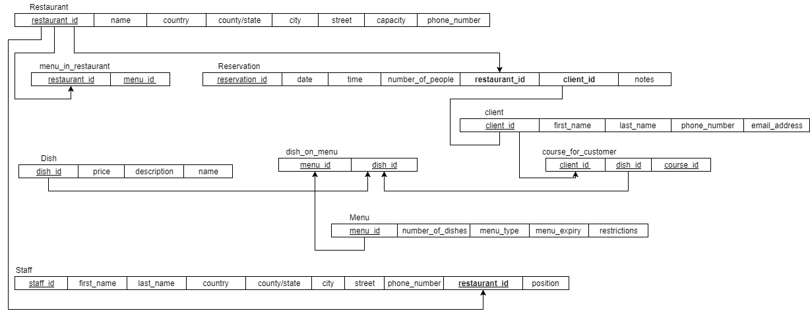

**Functional Dependency Diagram:**

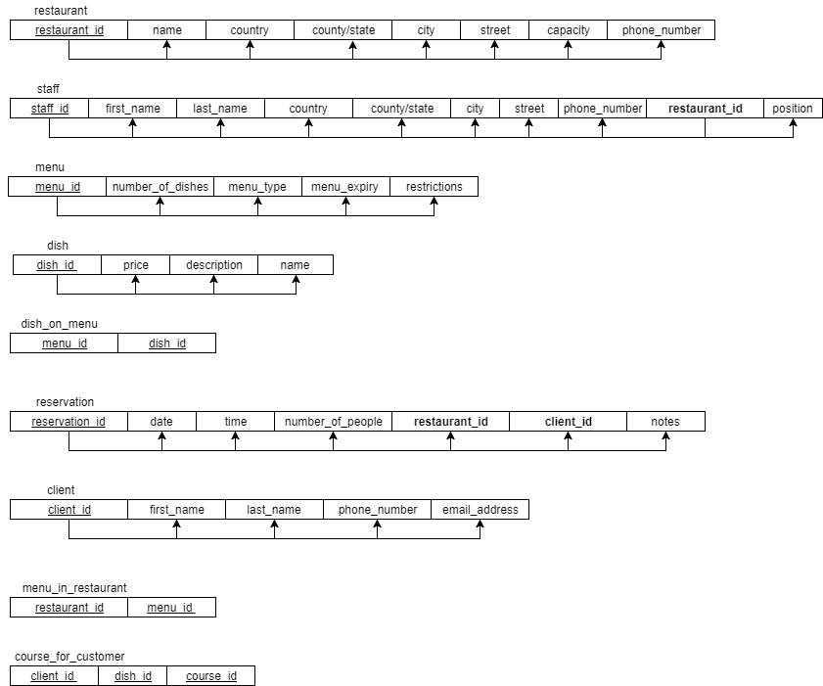

1. **Restaurant:**
   1. restaurant_id(name, country, state, city, street, capacity, phone_number)
2. **Staff:**
   1. staff_id(first_name, last_name, country, state, city, street, phone_number, position, **restaurant_id**)
3. **Menu:**
   1. menu_id(number_of_dishes, menu_type, menu_expiry, restrictions)
4. **Dish:**
   1. dish_id(price, description, name)
5. **Reservation:**
   1. reservation_id(date, time, number_of_people, **restaurant_id**, **client_id**, notes)
6. **Client:**
   1. client_id(first_name, last_name, phone_number, email_address)

It should be noted here, that in the extra table, **course_for_customer**, an extra primary key was added, which is the course_number. This is required to be part of the primary key of the table since a client can have many courses; starters, mains desserts for example. From adding this extra primary key, the composite primary key for course_for_customer is now (client_id, dish_id, course_id)

The other two extra tables are composed of pre-existing primary keys. The menu_in_restaurant is composed of two primary keys, making it a composite primary key composing of restaurant_id and menu_id, it relates a specific menu to a specific restaurant. The dish_on_menu table is also a composite primary key of dish_id and menu_id, relating a specific dish to a specific menu.

**Security considerations:**

Security in a database is an important consideration when designing and implementing a database, since an unsecure database can pose many risks such as data privacy violations. With reference to the database implemented, security is imperative because if there were no restrictions applied to the database, any member of staff could view other members of staff personal details; pay, PPSN etc.

The security policy that is being applied to this database is focused on user permission and authentications. In order to implement the security policies, some accounts need to be created and given the access permissions to the required tables. This is implemented using the key words - **CREATE ROLE**

The Roles that I have implemented in this database are as follows:

1. Manager
2. Chef
3. Waitress

To create the roles highlighted above the following commands were written:

1. Manager:

CREATE ROLE manager IDENTIFIED BY big_gordo;

GRANT CREATE, DELETE ON menu TO manager;

GRANT UPDATE, SELECT ON menu TO manager WITH GRANT OPTION;

GRANT DELETE, READ, UPDATE ON dish TO manager WITH GRANT OPTION;

GRANT CREATE, DELETE, UPDATE, READ ON client_reservation TO manager WITH GRANT OPTION

GRANT CREATE, DELETE, UPDATE, READ ON client TO manager WITH GRANT OPTION;

GRANT CREATE, DELETE, UPDATE ON staff TO manager;

GRANT SELECT ON staff TO manager WITH GRANT OPTION;

1. Chef:

CREATE ROLE chef IDENTIFIED BY big_gordo;

GRANT CREATE, UPDATE, SELECT ON menu TO chef;

GRANT UPDATE, DELETE ON dish, menu_Item TO chef;

GRANT SELECT ON menu_in_restaurant, course_for_customer TO chef;

1. Waitress:

CREATE ROLE waitress IDENTIFIED BY big_gordo;

GRANT UPDATE, DELETE, SELECT ON client_reservation, client TO waitress;

GRANT SELECT ON menu, restaurant, dish, dish_on_menu, menu_in_restaurant, dish_on_menu TO waitress;

GRANT UPDATE, DELETE, SELECT ON course_for_customer TO waitress;

These roles can then be given to staff in the database created as follows:

GRANT chef TO JohnnieDepp

GRANT waitress TO JamieOliver

GRANT manager TO BillySmith

To remove privileges from staff members, a command similar to the following can be used:

REVOKE DELETE ON dish FROM chef; // remove the chef’s right to remove a dish

Integrity and Semantic constraints:

* Entity Integrity constraints:
  + All primary, and hence foreign keys, were all specified as NOT NULL
* Referential Integrity Constraints:
  + Referential integrity was ensured by making sure all foreign keys are NOT NULL - which is done by setting all primary keys as NOT NULL.
* Semantic Constraints:
  + Semantic Constraints using CHECK:
    - Checks were used to ensure semantic constraints were met; such as the price for a dish or drink much be greater than or equal to zero. Example of constraints used are as follows:

CHECK (price>=0.0);

CHECK (capacity>0);

* + - etc.

**Triggers:**

* Triggers are activated on when specific events occur on relations in a database. When a trigger is activated, the defined instructions are executed. Triggers are very useful when it comes to keeping referential integrity in a database.
* A full list of the triggers used are shown below in the appendices. For an example of how triggers were used, I will explain with deleting a dish from a menu.
* When you want to delete a dish from a menu, it should be removed from the corresponding entry in dish_on_menu table, across every menu it’s present on.

CREATE OR REPLACE TRIGGER remove_item_from_menu

AFTER DELETE ON dish

FOR EACH ROW

WHEN (OLD.dish_id IS NOT NULL)

DECLARE

delete_dish_id INTEGER;

BEGIN

delete_dish_id =: OLD.dish_id;

DELETE dish_on_menu;

WHERE dish_on_menu.dish_id = delete_dish_id;

END;

.

RUN;

**Views:**

* Views are used to allow users a restricted view on particular tables and to aggregate information from different tables that are accessed regularly.
* A full list of the views implemented in this database can be viewed in the appendices. For an example of how views were used, I will explain with creating a view allowing wait staff to see basic details for reservations and client information.

CREATE VIEW view_reservations AS

SELECT client_reservation.reservation_date, client_reservation.reservation_time client.first_name, client.last_name, client.phone_number

FROM client_reservation, client

WHERE client_reservation.client_id = client.client_id;

**Querying the database:**

This section will show the results from some basic SQL commands on the database.

1. *SELECT * FROM client;*

|  |  |  |  |  |  |
| --- | --- | --- | --- | --- | --- |
|  | **client_id** | **first_name** | **last_name** | **phone_number** | **email_address** |
| 1 | 12051611558 | Gordon | Ramsay | 0876659854 | Gordo@gmail.com |
| 2 | 120116999 | Johnny | Williams | 0856924596 | jWill44@gmail.com |
| 3 | 120116159 | Benjamin | Bruce | 0867894563 | BenBruce89@hotmail.com |
| 4 | 1205165555 | Danny | Worsnop | 0857454568 | DSnop@gmail.com |
| 5 | 1205161568 | David | Beckham | 0875698596 | DBecks@gmail.com |

1. *SELECT first_name, last_name, email_address FROM client*

|  |  |  |  |
| --- | --- | --- | --- |
|  | **first_name** | **last_name** | **email_address** |
| 1 | Gordon | Ramsay | Gordo@gmail.com |
| 2 | Johnny | Williams | jWill44@gmail.com |
| 3 | Benjamin | Bruce | BenBruce89@hotmail.com |
| 4 | Danny | Worsnop | DSnop@gmail.com |
| 5 | David | Beckham | DBecks@gmail.com |

1. *SELECT client_reservation.reservation_date, client_reservation.reservation_time, client.first_name, client.last_name FROM client_reservation, client WHERE client_reservation.client_id = 1205165555 AND client_reservation.reservation_id = 0001;*

|  |  |  |  |
| --- | --- | --- | --- |
| **reservation_date** | **reservation_time** | **first_name** | **last_name** |
| 01-08-2017 | 16:45 | Danny | Worsnop |

**APPENDIX 1:**

Code used to create tables, triggers views etc.:

**CREATING TABLES FOR DATA:**

CREATE TABLE restaurant (

restaurant_id INTEGER NOT NULL,

name VARCHAR (25) NOT NULL,

country VARCHAR (63) NOT NULL,

state VARCHAR (63) NOT NULL,

city VARCHAR (63) NOT NULL,

street VARCHAR (63) NOT NULL,

capacity INTEGER NOT NULL,

phone_number INTEGER NOT NULL,

PRIMARY KEY (restaurant_id),

CHECK (capacity > 0)

);

CREATE TABLE staff (

staff_id INTEGER NOT NULL,

first_name VARCHAR (63) NOT NULL,

last_name VARCHAR (63) NOT NULL,

country VARCHAR (63) NOT NULL,

state VARCHAR (63) NOT NULL,

city VARCHAR (63) NOT NULL,

street VARCHAR (63) NOT NULL,

phone_number INTEGER,

restaurant_id INTEGER NOT NULL,

position VARCHAR (25) NOT NULL,

PRIMARY KEY (staff_id),

FOREIGN KEY (restaurant_id) REFERENCES restaurant (restaurant_id)

);

CREATE TABLE client (

client_id INTEGER NOT NULL,

First_name VARCHAR (63) NOT NULL,

last_name VARCHAR (63) NOT NULL,

phone_number INTEGER,

email_address VARCHAR (70),

PRIMARY KEY (client_id)

);

CREATE TABLE menu_in_restaurant (

restaurant_id INTEGER NOT NULL,

menu_id INTEGER NOT NULL,

PRIMARY KEY (restaurant_id, menu_id),

FOREIGN KEY (menu_id) REFERENCES menu (menu_id),

FOREIGN KEY (restaurant_id) REFERENCES restaurant (restaurant_id)

);

CREATE TABLE course_for_customer (

client_id INTEGER NOT NULL,

dish_id INTEGER NOT NULL,

course_id INTEGER NOT NULL,

PRIMARY KEY (client_id, dish_id, course_id),

FOREIGN KEY (dish_id) REFERENCES dish (dish_id),

FOREIGN KEY (client_id) REFERENCES client (client_id)

);

CREATE TABLE dish_on_menu (

menu_id INTEGER NOT NULL,

dish_id INTEGER NOT NULL,

PRIMARY KEY (menu_id, dish_id),

FOREIGN KEY (menu_id) REFERENCES menu (menu_id),

FOREIGN KEY (dish_id) REFERENCES dish (dish_id)

);

CREATE TABLE menu (

menu_id INTEGER NOT NULL,

menu_type VARCHAR (25) NOT NULL,

expiry VARCHAR (14),

number_of_dishes INTEGER NOT NULL,

restrictions VARCHAR (255),

PRIMARY KEY (menu_id),

CHECK(menu_type IN ('A La Carte', 'Seasonal', 'Wine Menu', 'Drinks Menu', 'Chefs Tasting Menu')),

CHECK (number_of_dishes > 0)

);

CREATE TABLE client_reservation (

reservation_id INTEGER NOT NULL,

reservation_date VARCHAR (10) NOT NULL,

reservation_time VARCHAR (5) NOT NULL,

num_clients INTEGER NOT NULL,

reservation_note VARCHAR (255),

restaurant_id INTEGER NOT NULL,

client_id INTEGER NOT NULL,

first_name

PRIMARY KEY (reservation_id),

FOREIGN KEY (restaurant_id) REFERENCES restaurant (restaurant_id),

FOREIGN KEY (client_id) REFERENCES client (client_id),

CHECK (num_clients > 0)

);

CREATE TABLE dish (

dish_id INTEGER NOT NULL,

price DECIMAL (6, 2),

name VARCHAR (255) NOT NULL,

description VARCHAR (255),

PRIMARY KEY (dish_id),

CONSTRAINT price_check CHECK (price>=0)

);

CREATE TABLE menu_in_restaurant (

restaurant_id INTEGER NOT NULL,

menu_id INTEGER NOT NULL,

PRIMARY KEY (restaurant_id, menu_id),

FOREIGN KEY (restaurant_id) REFERENCES restaurant (restaurant_id),

FOREIGN KEY (menu_id) REFERENCES menu (menu_id)

);

**Code for Triggers**

CREATE OR REPLACE TRIGGER closing_restaurant

AFTER DELETE ON restaurant

FOR EACH ROW

WHEN (OLD.restaurant_id IS NOT NULL)

DECLARE

delete_restaurant_id INTEGER

BEGIN

delete_restaurant_id:=: OLD.restaurant_id;

DELETE client_reservation

WHERE client_reservation.restaurant_id=delete_restaurant_id;

DELETE restaurant_menu

WHERE restaurant_menu.restaurant_id=delete_restaurant_id;

END;

.

RUN;

CREATE OR REPLACE TRIGGER remove_item_from_menu

AFTER DELETE ON dish

FOR EACH ROW

WHEN (OLD.dish_id IS NOT NULL)

DECLARE

delete_dish_id INTEGER;

BEGIN

delete_dish_id =: OLD.dish_id;

DELETE dish_on_menu;

WHERE dish_on_menu.dish_id = delete_dish_id;

END;

.

RUN;

CREATE OR REPLACE TRIGGER delete_info_on_client

AFTER DELETE ON client

FOR EACH ROW

WHEN (OLD.client_id IS NOT NULL)

DECLARE

delete_client_id INTEGER;

BEGIN

delete_client_id:=:OLD.client_id

DELETE client_reservation

WHERE client_reservation.client_id = delete_client_id;

DELETE course_for_customer

WHERE course_for_customer.client_id = delete_client_id;

END;

.

RUN;

CREATE OR REPLACE TRIGGER increment_num_items_on_menu

AFTER INSERT ON dish_on_menu

FOR EACH ROW

BEGIN

UPDATE menu m

SET m.number_of_dishes = m.number_of_dishes+1

WHERE m.menu_id =:NEW.menu_id;

END;

.

RUN;

CREATE OR REPLACE TRIGGER decrement_num_items_on_menu

AFTER DELETE ON dish_on_menu

FOR EACH ROW

BEGIN

UPDATE menu m

SET m.number_of_dishes = m.number_of_dishes-1

WHERE m.menu_id:=:NEW.menu_id;

END;

.

RUN;

**CREATE VIEWS:**

CREATE VIEW view_menu AS

SELECT dish.dish_id, dish.price, dish.description, dish_on_menu.menu_id

FROM dish, menu, dish_on_menu

WHERE menu.menu_id = dish_on_menu.menu_id AND dish.dish_id=dish_on_menu.dish_id;

CREATE VIEW view_reservations AS

SELECT client_reservation.reservation_date, client_reservation.reservation_time client.first_name, client.last_name, client.phone_number

FROM client_reservation, client

WHERE client_reservation.client_id = client.client_id;

END;

.

RUN;

**APPENDIX 2:**

Inserting data into the created tables:

**INSERT DATA INTO RESTAURANT TABLE:**

INSERT INTO restaurant VALUES (0005, 'Le Pressoir dArgent', 'France', 'Aquitaine', 'Bordeaux', 'Place de la Comédie', 190, 557304304);

INSERT INTO restaurant VALUES (0004, 'York and Albany', 'United Kingdom', 'Greater London', 'London', 'Gloucester Gate Bridge', 225, 2073875700);

INSERT INTO restaurant VALUES (0003, 'FORTE VILLAGE', 'Sardinia', 'Cagliari', 'Cagliari', 'Strada Statale 195 Sulcitana', 175, 0709218818);

INSERT INTO restaurant VALUES (0002, 'RESTAURANT GORDON RAMSAY', 'United Kingdom', 'Greater London', 'London', 'Royal Hospital Road', 125, 2073524441);

INSERT INTO restaurant VALUES (0001, 'PETRUS', 'United Kingdom', 'Greater London', 'London', 'Knightsbridge', 150, 2075921609);

**INSERT DATA INTO CLIENT RESERVATION TABLE:**

INSERT INTO client_reservation VALUES (010120169584, '01-01-2016', '16:30', 3, 'please not a seat by the door', 0001, 120116999, 'Johnny');

INSERT INTO client_reservation VALUES (0101201656514, '01-01-2016', '16:30', 3, ' ', 0001, 120116159,'Benjamin');

INSERT INTO client_reservation VALUES (01012018954, '01-08-2017', '16:45', 5, ' ', 0003, 1205161568,'David');

INSERT INTO client_reservation VALUES (010124544, '01-08-2017', '16:45', 5, ' ', 0002, (1205165555,'Danny') ;

INSERT INTO client_reservation VALUES (011535154, '01-08-2017', '16:45', 5, 'vegan friendly menu please –and dont tell me f*ck off...’, 0002, 120116999, 'Johnny');

**INSERT DATA INTO STAFF TABLE - Petrus restaurant:**

INSERT INTO staff VALUES (00045651, 'Billy', 'Smith', 'United Kingdom', 'Greater London', 'London', 'Hatch Street', 0873259685, 0001, 'Chef');

INSERT INTO staff VALUES (045454551, 'Jamie', 'Oliver', 'United Kingdom', 'Greater London', 'London’, ‘Queens Street', 0857965698, 0001, 'Potato Peeler');

INSERT INTO staff VALUES (0454654651, 'Alice', 'Clarke', 'United Kingdom', 'Greater London', 'London’, ‘Buckingham Palace', 0859685754, 0001, 'Waitress');

INSERT INTO staff VALUES (045445641, 'Alice', 'Clarke', 'United Kingdom', 'Greater London', 'London', 'London Street', 0875698754,0001,'Sommelier');

INSERT INTO staff VALUES (004555551, 'Susy', 'Monaghan', 'United Kingdom', 'Greater London', 'London’, ‘Bridge Street', 0874563215, 0001, 'Manager’');

**INSERT DATA INTO STAFF TABLE - restaurant Gordon Ramsay:**

INSERT INTO staff VALUES (0454521, 'Molly', 'Malone', 'United Kingdom', 'Greater London', 'London’, ‘Cockle and Mussels Street', 0878965897, 0002, 'Chef');

INSERT INTO staff VALUES (044564151, 'Brian', 'Boru', 'United Kingdom', 'Greater London', 'London', 'Munster Street', 0879685745, 0002, Manager');

INSERT INTO staff VALUES (044541561, 'Jimmy', 'Higgins', 'United Kingdom', 'Greater London', 'London', 'Leinster Street', 0875, 0002, 'Sommelier');

INSERT INTO staff VALUES (044546661, 'Hannah', 'Blythe', 'United Kingdom', 'Greater London', 'London’, ‘Memphis Street', 0876598655, 0002, 'Waitress');

INSERT INTO staff VALUES (0046565551, 'John', 'Baker', 'United Kingdom', 'Greater London', 'London', 'Harry Street', 0875696854, 0002, 'Baker');

**INSERT DATA INTO STAFF TABLE - Forte Village:**

INSERT INTO staff VALUES (04498651, 'Gorgio', 'Giovanni', 'Sardinia', 'Cagliari', 'Cagliari', 'Via Italia', 0889861235, 0003, 'Chef');

INSERT INTO staff VALUES (0444156416, 'Leo', 'Da Vinci', 'Sardinia', 'Cagliari', 'Cagliari', 'Via Arduino', 0889865423, 0003, 'Pasta Maker');

INSERT INTO staff VALUES (044454416, 'Michelangelo', 'Merisi Da Caravaggio', 'Sardinia', 'Cagliari', 'Cagliari', Via Toscana', 088754879665, 0003, 'Waiter');

INSERT INTO staff VALUES (04565666, 'Papa', 'Francesco', 'Sardinia', 'Cagliari', 'Cagliari', 'Via Firenze', 08878965452, 0003, 'Sommelier');

INSERT INTO staff VALUES (45646546, 'Massimo', 'Bottura', 'Sardinia', 'Cagliari', 'Cagliari', 'Via Roma', 0858965284, 0003, ‘Manager’');

**INSERT DATA INTO STAFF TABLE - York and Albany:**

INSERT INTO staff VALUES (44564566, 'Tony', 'Winters', 'United Kingdom', 'Greater London', 'London', 'Big Ben Street', 0858965858, 0004, 'Chef');

INSERT INTO staff VALUES (4564566, 'Marco', 'Italiano', 'United Kingdom', 'Greater London', 'London’, ‘London Eye Street', 0857898986, 0004, 'Sous Chef');

INSERT INTO staff VALUES (44556466, 'P.C.', 'Principal', 'United Kingdom', 'Greater London', 'London', 'South Park Street', 0857596872, 0004, 'Sommelier');

INSERT INTO staff VALUES (445666, 'Eric', 'Cartman', 'United Kingdom', 'Greater London', 'London', 'East Park Street', 0857896542, 0004, 'Waiter');

INSERT INTO staff VALUES (789456123, 'Randy', 'Marsh', 'United Kingdom', 'Greater London', 'London', 'North Park Street', 0857896542, 0004, ‘Manager’);

**INSERT DATA INTO STAFF TABLE - Le Pressoir d'Argent:**

INSERT INTO staff VALUES (789456123, 'Randy', 'Marsh', 'United Kingdom', 'Greater London', 'London', 'North Park Street', 0857896542, 0004, 'Expeditor');

INSERT INTO staff VALUES (456789, 'Timothee', 'Troncy', 'France', 'Aquitaine', 'Bordeaux', 'Rue Abel', 0857895645, 0005, 'Chef');

INSERT INTO staff VALUES (478955, 'Raymond', 'Blanc', 'France', 'Aquitaine', 'Bordeaux', 'Avenue Carnot',0857856352, 0005, 'Sommelier');

INSERT INTO staff VALUES (44545455, 'Michel', 'Roux', 'France', 'Aquitaine', 'Bordeaux', 'Rue Clairaut', 0852563632, 0005, 'Sous Chef');

INSERT INTO staff VALUES (44545456, 'Michel', 'Roux JR', 'France', 'Aquitaine', 'Bordeaux', 'Rue Serret', 0854562569, 0005, 'Manager');

**INSERT DATA INTO MENU TABLE - Petrus restaurant menus:**

INSERT INTO menu VALUES (000101, 'A La Carte', 'September-2018', 0, '');

INSERT INTO menu VALUES (000102, 'Wine Menu', 'September-2018', 0, 'Over 18s ONLY');

INSERT INTO menu VALUES (000103, 'Drinks Menu', 'September-2018', 0, 'Over 18s ONLY');

INSERT INTO menu VALUES (000104, 'Seasonal', 'January-2018', 0, '');

INSERT INTO menu VALUES (000105, 'Chef's Tasting Menu', 'January-2018', 0, '');

**INSERT DATA INTO MENU TABLE - restaurant Gordon Ramsay menus:**

INSERT DATA INTO MENU TABLE - Petrus restaurant menus

INSERT INTO menu VALUES (000202, 'Wine Menu', 'September-2018', 0, 'Over 18s ONLY');

INSERT INTO menu VALUES (000203, 'Drinks Menu', 'September-2018', 0, 'Over 18s ONLY');

INSERT INTO menu VALUES (000204, 'Seasonal', 'January-2018', 0, '');

INSERT INTO menu VALUES (000205, 'Chef's Tasting Menu', 'January-2018', 0, '');

**INSERT DATA INTO MENU TABLE - Forte Village restaurant menus:**

INSERT INTO menu VALUES (000301, 'A La Carte', 'September-2018', 0, '');

INSERT INTO menu VALUES (000302, 'Wine Menu', 'September-2018', 0, 'Over 16s ONLY');

INSERT INTO menu VALUES (000303, 'Drinks Menu', 'September-2018', 0, 'Over 16s ONLY');

INSERT INTO menu VALUES (000304, 'Seasonal', 'January-2018', 0, '');

INSERT INTO menu VALUES (000305, 'Chef's Tasting Menu', 'January-2018', 0, '');

**INSERT DATA INTO MENU TABLE - York and Albany restaurant menus:**

INSERT INTO menu VALUES (000401, 'A La Carte', 'September-2018', 0, '');

INSERT INTO menu VALUES (000402, 'Wine Menu', 'September-2018', 0, 'Over 18s ONLY');

INSERT INTO menu VALUES (000403, 'Drinks Menu', 'September-2018', 0, 'Over 18s ONLY');

INSERT INTO menu VALUES (000404, 'Seasonal', 'January-2018', 0, '');

INSERT INTO menu VALUES (000405, 'Chef's Tasting Menu', 'January-2018', 0, '');

**INSERT DATA INTO MENU TABLE - Le Pressoir d'Argent restaurant menus:**

INSERT INTO menu VALUES (000501, 'A La Carte', 'September-2018', 0, '');

INSERT INTO menu VALUES (000502, 'Wine Menu', 'September-2018', 0, 'Over 16s ONLY');

INSERT INTO menu VALUES (000503, 'Drinks Menu', 'September-2018', 0, 'Over 16s ONLY');

INSERT INTO menu VALUES (000504, 'Seasonal', 'January-2018', 0, '');

INSERT INTO menu VALUES (000505, 'Chef's Tasting Menu', 'January-2018', 0, '');

**INSERT DATA INTO DISH TABLE - Petrus - food and drink:**

INSERT INTO dish VALUES (10100, 15.50, 'smoked eel, Oscietra Caviar, Cauliflower, turmeric, dill', '');

INSERT INTO dish VALUES (20100, 15.50, 'Seared curried Orkney scallop, braised kombu, bacon, egg sabayon', ‘‘);

INSERT INTO dish VALUES (30100, 15.50, 'Steak tartare, crispy tendons, cornichons, nasturtium, egg yolk', '');

INSERT INTO dish VALUES (40100, 15.50, 'Roasted Veal sweetbread, polenta, king oyster mushrooms', '');

INSERT INTO dish VALUES (50100, 15.50, 'Roasted Onion Broth, pumpkin gnocchi, shiitake, mandarin', '');

INSERT INTO dish VALUES (60100, 15.50, 'Salt baked beetroots, poached quince, goats cheese, horseradish', '');

INSERT INTO dish VALUES (70100, 15.50, 'Fillet of Gigha Island Halibut, cuttlefish, rouille, fennel, bouillabaisse sauce', '');

INSERT INTO dish VALUES (80100, 15.50, 'Fillet of Brixham turbot, pickled cockles, samphire, lemongrass', '£5.00 supplement');

INSERT INTO dish VALUES (90100, 15.50, 'Poulet de Bresse, foie gras, cep mushrooms, leek soubise', '');

INSERT INTO dish VALUES (100100, 15.50, 'Saddle of rabbit - belle époque, lobster and rabbit lasagna, carrots, chanterelle', '');

INSERT INTO dish VALUES (110100, 15.50, 'Fresh Linguine, seasonal mushrooms, 36-month-old parmesan volute', '');

INSERT INTO dish VALUES (120100, 56.50, '1964 Chateauneuf du pape', '');

INSERT INTO dish VALUES (130100, 50.00, '2001 Bordeaux', '');

INSERT INTO dish VALUES (140100, 36.00, '2005 Tokaji', '');

INSERT INTO dish VALUES (150100, 33.00, '2005 Vernaccia di San Gimignano', '');

INSERT INTO dish VALUES (160100, 55.00, '2015 Chardonnay', '');

INSERT INTO dish VALUES (170100, 7.00, 'Talisker 10', '');

INSERT INTO dish VALUES (180100, 8.50, 'Oban 14', '');

INSERT INTO dish VALUES (190100, 6.50, 'Bruichladdich the Laddie', '');

INSERT INTO dish VALUES (200100, 6.50, 'Glenfiddich', '');

INSERT INTO dish VALUES (210100, 9.50, 'Glenfarclas', '');

INSERT INTO dish VALUES (220100, 6.50, 'Woodford Reserve', '');

**INSERT dish INTO menu – Petrus:**

INSERT INTO dish_on_menu VALUES (00101, 10100);

INSERT INTO dish_on_menu VALUES (00101, 20100);

INSERT INTO dish_on_menu VALUES (00101, 30100);

INSERT INTO dish_on_menu VALUES (00101, 40100);

INSERT INTO dish_on_menu VALUES (00101, 50100);

INSERT INTO dish_on_menu VALUES (00102, 120100);

INSERT INTO dish_on_menu VALUES (00102, 130100);

INSERT INTO dish_on_menu VALUES (00102, 140100);

INSERT INTO dish_on_menu VALUES (00102, 150100);

INSERT INTO dish_on_menu VALUES (00102, 160100);

INSERT INTO dish_on_menu VALUES (00103, 170100);

INSERT INTO dish_on_menu VALUES (00103, 180100);

INSERT INTO dish_on_menu VALUES (00103, 190100);

INSERT INTO dish_on_menu VALUES (00103, 200100);

INSERT INTO dish_on_menu VALUES (00103, 210100);

INSERT INTO dish_on_menu VALUES (00104, 120100);

INSERT INTO dish_on_menu VALUES (00104, 110100);

INSERT INTO dish_on_menu VALUES (00104, 090100);

INSERT INTO dish_on_menu VALUES (00104, 070100);

INSERT INTO dish_on_menu VALUES (00104, 060100);

INSERT INTO dish_on_menu VALUES (00105, 100100);

INSERT INTO dish_on_menu VALUES (00105, 060100);

INSERT INTO dish_on_menu VALUES (00105, 050100);

INSERT INTO dish_on_menu VALUES (00105, 030100);

INSERT INTO dish_on_menu VALUES (00105, 110100);

**INSERT DATA INTO DISH TABLE - restaurant Gordon Ramsay - food and drink**

INSERT INTO dish VALUES (10200, 17.50, 'lobster, langoustine, salmon, oxalis and wood sorrel', '');

INSERT INTO dish VALUES (20200, 17.50, 'Cornish brown crab, lovage, lemon thyme, English muffins', '');

INSERT INTO dish VALUES (30200, 17.50, 'pan fried scallops from the Isle of Skye, heritage apples, walnuts, celery, cider', '');

INSERT INTO dish VALUES (40200, 17.50, 'pressed foie gras, green apples, turnips, watercress, smoked duck', ‘‘);

INSERT INTO dish VALUES (50200, 17.50, 'sautéed foie gras, clementine, nasturtium, sauternes', '');

INSERT INTO dish VALUES (60200, 17.50, 'Suckling pig, crispy belly, roasted loin, spiced shoulder sausage, Chou farci, crushed potatoes', '');

INSERT INTO dish VALUES (70200, 17.50, 'dover sole, shiso, shellfish, celtuce, shiitake', '');

INSERT INTO dish VALUES (80200, 17.50, 'roast pigeon, beetroot, quince, buckwheat', '');

INSERT INTO dish VALUES (90200, 17.50, 'Cornish turbot, chanterelles, black garlic, langoustine', '');

INSERT INTO dish VALUES (100200, 17.50, 'braised, confit and roasted Hardwick lamb, winter vegetable - navarin’, '');

INSERT INTO dish VALUES (110200, 17.50, 'slow cooked egg, celeriac, Iberico ham, vin jaune', '');

INSERT INTO dish VALUES (120200, 56.50, '1996 Brunello Di Montalcino', '');

INSERT INTO dish VALUES (130200, 50.00, '2001 Bordeaux', '');

INSERT INTO dish VALUES (140200, 36.00, '2005 Tokaji', '');

INSERT INTO dish VALUES (150200, 33.00, '2005 Vernaccia di San Gimignano', '');

INSERT INTO dish VALUES (160200, 55.00, '2015 Chardonnay', '');

INSERT INTO dish VALUES (170200, 7.00, 'Laphroaig 10', '');

INSERT INTO dish VALUES (180200, 8.50, 'Oban 14', '');

INSERT INTO dish VALUES (190200, 20.50, 'Bruichladdich Black Art 4.1', '');

INSERT INTO dish VALUES (200200, 19.50, 'Midleton 2018', '');

INSERT INTO dish VALUES (210200, 9.50, 'Glenfarclas', '');

INSERT INTO dish VALUES (220200, 6.50, 'Woodford Reserve', '');

**INSERT dish INTO menu - restaurant Gordon Ramsay:**

INSERT INTO dish_on_menu VALUES (00101, 10100);

INSERT INTO dish_on_menu VALUES (00201, 20200);

INSERT INTO dish_on_menu VALUES (00201, 30200);

INSERT INTO dish_on_menu VALUES (00201, 40200);

INSERT INTO dish_on_menu VALUES (00201, 50200);

INSERT INTO dish_on_menu VALUES (00202, 120200);

INSERT INTO dish_on_menu VALUES (00202, 130200);

INSERT INTO dish_on_menu VALUES (00202, 120200);

INSERT INTO dish_on_menu VALUES (00202, 150200);

INSERT INTO dish_on_menu VALUES (00202, 160200);

INSERT INTO dish_on_menu VALUES (00203, 170200);

INSERT INTO dish_on_menu VALUES (00203, 180200);

INSERT INTO dish_on_menu VALUES (00203, 190200);

INSERT INTO dish_on_menu VALUES (00203, 200200);

INSERT INTO dish_on_menu VALUES (00203, 210200);

INSERT INTO dish_on_menu VALUES (00204, 120200);

INSERT INTO dish_on_menu VALUES (00204, 110200);

INSERT INTO dish_on_menu VALUES (00204, 090200);

INSERT INTO dish_on_menu VALUES (00204, 070200);

INSERT INTO dish_on_menu VALUES (00204, 060200);

INSERT INTO dish_on_menu VALUES (00205, 100200);

INSERT INTO dish_on_menu VALUES (00205, 060200);

INSERT INTO dish_on_menu VALUES (00205, 050200);

INSERT INTO dish_on_menu VALUES (00205, 030200);

INSERT INTO dish_on_menu VALUES (00205, 110200);

**INSERT DATA INTO DISH TABLE - Forte Village restaurant - food and drink:**

INSERT INTO dish VALUES (10300, 17.50, 'foie gras, red onion sorbet, yogurt and raspberries', '');

INSERT INTO dish VALUES (20300, 17.50, 'carpaccio of scallop marinated in almond milk and cedar, Salicornia salad and tapioca caviar', '');

INSERT INTO dish VALUES (30300, 17.50, 'selection of vegetables in summer projection', '');

INSERT INTO dish VALUES (40300, 17.50, 'Summer Toast', 'Oysters, Strawberries, Champagne');

INSERT INTO dish VALUES (50300, 17.50, 'Lobster Ravioli wrapped with lard from colonnata and froth', '');

INSERT INTO dish VALUES (60300, 17.50, 'roast pigeon, beetroot, quince, buckwheat', '');

INSERT INTO dish VALUES (70300, 17.50, 'slow cooked eff, celeriac, Iberico ham, vin jaune', '');

INSERT INTO dish VALUES (80300, 17.50, 'dover sole, shiso, shellfish, celtuce, shiitake', '');

INSERT INTO dish VALUES (90300, 17.50, 'sautéed foie gras, clementine, nasturtium, sauternes', '');

INSERT INTO dish VALUES (100300, 17.50, 'lobster, langoustine, salmon, oxalis and wood sorrel', '');

INSERT INTO dish VALUES (110300, 17.50, 'Cornish brown crab, lovage, lemon thyme, English muffins', '');

INSERT INTO dish VALUES (120300, 56.50, '2005 Malvasia di Bosa', '');

INSERT INTO dish VALUES (130300, 50.00, '2001 Bordeaux', '');

INSERT INTO dish VALUES (140300, 36.00, '2005 Tokaji', '');

INSERT INTO dish VALUES (150300, 33.00, '2005 Vernaccia di San Gimignano', '');

INSERT INTO dish VALUES (160300, 55.00, '2015 Chardonnay', '');

INSERT INTO dish VALUES (170300, 7.00, 'Laphroaig 10', '');

INSERT INTO dish VALUES (180300, 8.50, 'Oban 14', '');

INSERT INTO dish VALUES (190300, 20.50, 'Bruichladdich Black Art 4.1', '');

INSERT INTO dish VALUES (200300, 19.50, 'Midleton 2018', '');

INSERT INTO dish VALUES (210300, 9.50, 'Glengoyne 12', '');

INSERT INTO dish VALUES (220300, 6.50, 'Woodford Reserve', '');

**INSERT dish INTO menu - Forte village:**

INSERT INTO dish_on_menu VALUES (00301, 10300);

INSERT INTO dish_on_menu VALUES (00301, 20300);

INSERT INTO dish_on_menu VALUES (00301, 30300);

INSERT INTO dish_on_menu VALUES (00301, 40300);

INSERT INTO dish_on_menu VALUES (00301, 50300);

INSERT INTO dish_on_menu VALUES (00302, 120300);

INSERT INTO dish_on_menu VALUES (00302, 130300);

INSERT INTO dish_on_menu VALUES (00302, 140300);

INSERT INTO dish_on_menu VALUES (00302, 150300);

INSERT INTO dish_on_menu VALUES (00302, 160300);

INSERT INTO dish_on_menu VALUES (00303, 170300);

INSERT INTO dish_on_menu VALUES (00303, 180300);

INSERT INTO dish_on_menu VALUES (00303, 190300);

INSERT INTO dish_on_menu VALUES (00303, 200300);

INSERT INTO dish_on_menu VALUES (00303, 210300);

INSERT INTO dish_on_menu VALUES (00304, 120300);

INSERT INTO dish_on_menu VALUES (00304, 110300);

INSERT INTO dish_on_menu VALUES (00304, 090300);

INSERT INTO dish_on_menu VALUES (00304, 070300);

INSERT INTO dish_on_menu VALUES (00304, 060300);

INSERT INTO dish_on_menu VALUES (00305, 100300);

INSERT INTO dish_on_menu VALUES (00305, 060300);

INSERT INTO dish_on_menu VALUES (00305, 050300);

INSERT INTO dish_on_menu VALUES (00305, 030300);

INSERT INTO dish_on_menu VALUES (00305, 110300);

**INSERT DATA INTO DISH TABLE - York and Albany restaurant - food and drink:**

INSERT INTO dish VALUES (10400, 20.50, 'Jerusalem artichoke soup', '');

INSERT INTO dish VALUES (20400, 20.50, 'seared scallops haggis, parsley rooz', '');

INSERT INTO dish VALUES (30400, 20.50, 'oak smoked mackerel, heritage beetroot, dill', '');

INSERT INTO dish VALUES (40400, 20.50, 'roast sea-bream, pak-choi, chili, sesame, lotus root', '');

INSERT INTO dish VALUES (50400, 20.50, 'venison shoulder ragu, chestnut pappardelle', '');

INSERT INTO dish VALUES (60400, 20.50, 'braised lamb neck, fennel garlic mash', '');

INSERT INTO dish VALUES (70400, 20.50, 'Y&A burger, chunky chips', '');

INSERT INTO dish VALUES (80400, 20.50, '28 day ages west country rib eye', '');

INSERT INTO dish VALUES (90400, 20.50, 'lake district pork bone', '');

INSERT INTO dish VALUES (100400, 20.50, 'pressed rabbit & ham hock terrine, pickled mustard seeds', '');

INSERT INTO dish VALUES (110400, 20.50, 'corn fed chicken supreme, braised puy lentils', '');

INSERT INTO dish VALUES (120400, 56.50, '2005 Malvasia di Bosa', '');

INSERT INTO dish VALUES (130400, 50.00, '2001 Merlot', '');

INSERT INTO dish VALUES (140400, 36.00, '2005 Tokaji', '');

INSERT INTO dish VALUES (150400, 33.00, '2005 Pinot Gris', '');

INSERT INTO dish VALUES (160400, 55.00, '2015 Chardonnay', '');

INSERT INTO dish VALUES (170400, 7.00, Chivas Royal', '');

INSERT INTO dish VALUES (180400, 8.50, 'Oban 14', '');

INSERT INTO dish VALUES (190400, 20.50, 'Bruichladdich Black Art 4.1', '');

INSERT INTO dish VALUES (200400, 19.50, 'Midleton 2018', '');

INSERT INTO dish VALUES (210400, 9.50, 'Glenlivet 12', '');

INSERT INTO dish VALUES (220400, 6.50, Kilchoman sherry finish, '');

**INSERT dish INTO menu - York and Albany:**

INSERT INTO dish_on_menu VALUES (00401, 10100);

INSERT INTO dish_on_menu VALUES (00401, 20400);

INSERT INTO dish_on_menu VALUES (00401, 30400);

INSERT INTO dish_on_menu VALUES (00401, 40400);

INSERT INTO dish_on_menu VALUES (00401, 50400);

INSERT INTO dish_on_menu VALUES (00402, 120400);

INSERT INTO dish_on_menu VALUES (00402, 130400);

INSERT INTO dish_on_menu VALUES (00402, 140400);

INSERT INTO dish_on_menu VALUES (00402, 150400);

INSERT INTO dish_on_menu VALUES (00402, 160400);

INSERT INTO dish_on_menu VALUES (00403, 170400);

INSERT INTO dish_on_menu VALUES (00403, 180400);

INSERT INTO dish_on_menu VALUES (00403, 190400);

INSERT INTO dish_on_menu VALUES (00403, 200400);

INSERT INTO dish_on_menu VALUES (00403, 210400);

INSERT INTO dish_on_menu VALUES (00404, 120400);

INSERT INTO dish_on_menu VALUES (00404, 110400);

INSERT INTO dish_on_menu VALUES (00404, 090400);

INSERT INTO dish_on_menu VALUES (00404, 070400);

INSERT INTO dish_on_menu VALUES (00404, 060400);

INSERT INTO dish_on_menu VALUES (00405, 100400);

INSERT INTO dish_on_menu VALUES (00405, 060400);

INSERT INTO dish_on_menu VALUES (00405, 050400);

INSERT INTO dish_on_menu VALUES (00405, 030400);

INSERT INTO dish_on_menu VALUES (00405, 110400);

**INSERT DATA INTO DISH TABLE - le Pressoir d'Argent restaurant - food and drink:**

INSERT INTO dish VALUES (10500, 50.50, 'Saint-Jean-de-Luz spider crab with avocado, pomelo, coriander, radishes and citrus dressing', '');

INSERT INTO dish VALUES (20500, 50.50, 'Bazas beef tartar, oyster cream, Aquitaine caviar and wood sorrel', '');

INSERT INTO dish VALUES (30500, 50.50, 'Confit organic egg with ceps, Noir de Bigorre ham, smoked chestnuts, onion velouté', '');

INSERT INTO dish VALUES (40500, 50.50, 'Roasted veal sweetbread, carrots, fennel, caraway', '');

INSERT INTO dish VALUES (50500, 50.50, 'Sautéed foie gras with black figs, yellow beetroot, smoked duck, Timut pepper and Muscat grapes', '');

INSERT INTO dish VALUES (60500, 50.50, 'Sole ‘petit bateau’ with young leek, black truffle, duxelles and vin jaune’, '');

INSERT INTO dish VALUES (70500, 50.50, 'Native lobster from the ‘press’, cooked with lemon leaves, sweetcorn, zucchini and chanterelles', '');

INSERT INTO dish VALUES (80500, 50.50, 'Lightly smoked venison with sautéed foie gras, red cabbage, parsnip, Manjari chocolate and Pedro Ximenez', '');

INSERT INTO dish VALUES (90500, 50.50, 'Roasted Landes chicken ‘demi-deuil’, salsify, wild mushrooms, truffle pomme purée, jus gras', '');

INSERT INTO dish VALUES (100500, 20.50, 'Lemon and caramel ‘crisp’ with lemon caviar and sorbet', '');

INSERT INTO dish VALUES (110500, 20.50, 'Frozen exotic fruit mousse, honeyed marmalade', '');

INSERT INTO dish VALUES (120500, 56.50, '2005 Malvasia di Bosa', '');

INSERT INTO dish VALUES (130500, 50.00, '2001 Merlot', '');

INSERT INTO dish VALUES (140500, 36.00, '2005 Tokaji', '');

INSERT INTO dish VALUES (150500, 33.00, '2005 Pinot Gris', '');

INSERT INTO dish VALUES (160500, 55.00, '2015 Chardonnay', '');

INSERT INTO dish VALUES (170500, 7.00, 'Laphroaig QA cask', '');

INSERT INTO dish VALUES (180500, 8.50, 'Oban 14', '');

INSERT INTO dish VALUES (190500, 20.50, 'Bruichladdich Black Art 4.1', '');

INSERT INTO dish VALUES (200500, 19.50, 'Midleton 2018', '');

INSERT INTO dish VALUES (210500, 9.50, 'Glengoyne 12', '');

INSERT INTO dish VALUES (220500, 6.50, 'Woodford Reserve - Double wood', '');

**INSERT dish INTO menu – le Pressoir d'Argent restaurant:**

INSERT INTO dish_on_menu VALUES (00501, 10500);

INSERT INTO dish_on_menu VALUES (00501, 20500);

INSERT INTO dish_on_menu VALUES (00501, 30500);

INSERT INTO dish_on_menu VALUES (00501, 40500);

INSERT INTO dish_on_menu VALUES (00501, 50500);

INSERT INTO dish_on_menu VALUES (00502, 120500);

INSERT INTO dish_on_menu VALUES (00502, 130500);

INSERT INTO dish_on_menu VALUES (00502, 140500);

INSERT INTO dish_on_menu VALUES (00502, 150500);

INSERT INTO dish_on_menu VALUES (00502, 160500);

INSERT INTO dish_on_menu VALUES (00503, 170500);

INSERT INTO dish_on_menu VALUES (00503, 180500);

INSERT INTO dish_on_menu VALUES (00503, 190500);

INSERT INTO dish_on_menu VALUES (00503, 200500);

INSERT INTO dish_on_menu VALUES (00503, 210500);

INSERT INTO dish_on_menu VALUES (00504, 120500);

INSERT INTO dish_on_menu VALUES (00504, 110500);

INSERT INTO dish_on_menu VALUES (00504, 090500);

INSERT INTO dish_on_menu VALUES (00504, 070500);

INSERT INTO dish_on_menu VALUES (00504, 060500);

INSERT INTO dish_on_menu VALUES (00505, 100500);

INSERT INTO dish_on_menu VALUES (00505, 060500);

INSERT INTO dish_on_menu VALUES (00505, 050500);

INSERT INTO dish_on_menu VALUES (00505, 030500);

INSERT INTO dish_on_menu VALUES (00505, 110500);

**INSERT DATA INTO MENU IN RESTAURANTS:**

INSERT INTO menu_in_restaurant VALUES (0001, 00101);

INSERT INTO menu_in_restaurant VALUES (0001, 00102);

INSERT INTO menu_in_restaurant VALUES (0001, 00103);

INSERT INTO menu_in_restaurant VALUES (0001, 00104);

INSERT INTO menu_in_restaurant VALUES (0001, 00105);

INSERT INTO menu_in_restaurant VALUES (0002, 00201);

INSERT INTO menu_in_restaurant VALUES (0002, 00202);

INSERT INTO menu_in_restaurant VALUES (0002, 00203);

INSERT INTO menu_in_restaurant VALUES (0002, 00204);

INSERT INTO menu_in_restaurant VALUES (0002, 00205);

INSERT INTO menu_in_restaurant VALUES (0003, 00301);

INSERT INTO menu_in_restaurant VALUES (0003, 00302);

INSERT INTO menu_in_restaurant VALUES (0003, 00303);

INSERT INTO menu_in_restaurant VALUES (0003, 00304);

INSERT INTO menu_in_restaurant VALUES (0003, 00305);

INSERT INTO menu_in_restaurant VALUES (0004, 00401);

INSERT INTO menu_in_restaurant VALUES (0004, 00402);

INSERT INTO menu_in_restaurant VALUES (0004, 00403);

INSERT INTO menu_in_restaurant VALUES (0004, 00404);

INSERT INTO menu_in_restaurant VALUES (0004, 00405);

INSERT INTO menu_in_restaurant VALUES (0005, 00501);

INSERT INTO menu_in_restaurant VALUES (0005, 00502);

INSERT INTO menu_in_restaurant VALUES (0005, 00503);

INSERT INTO menu_in_restaurant VALUES (0005, 00504);

INSERT INTO menu_in_restaurant VALUES (0005, 00505);

**INSERT DATA INTO CLIENT TABLE:**

INSERT INTO client VALUES (12051611558, 'Gordon', 'Ramsay', 0876659854, 'Gordo@gmail.com');

INSERT INTO client VALUES (120116999, 'Johnny', 'Williams', 0856924596, 'jWill44@gmail.com');

INSERT INTO client VALUES (120116159, 'Benjamin', 'Bruce', 0867894563, 'BenBruce89@hotmail.com');

INSERT INTO client VALUES (1205165555, 'Danny', 'Worsnop', 0857454568, 'DSnop@gmail.com');

INSERT INTO client VALUES (1205161568, 'David', 'Beckham', 0875698596, 'DBecks@gmail.com');

**INSERT DATA INTO course_for_customer:**

INSERT INTO course_for_customer VALUES (12051611558, 10500, 0);

INSERT INTO course_for_customer VALUES (120116999, 200400, 1);

INSERT INTO course_for_customer VALUES (120116159, 070300, 2);

INSERT INTO course_for_customer VALUES (1205165555, 160400, 3);

INSERT INTO course_for_customer VALUES (1205161568, 050300, 1);